**Implementation of 3-Tier Architecture on Microsoft Azure**

Prepared by:

**Virat Pandey**

Celebal Technology

Cloud Infrastructure & Security Internship

**Final Project**

July , 2025

# Table of Contents

* Project Objective
* Architecture Overview
* Azure Resource Setup
* Network Security Groups (NSGs)
* VM Deployment and Configuration
* Web Tier Setup (IIS + HTML + API Call)
* App Tier Setup (Backend API)
* DB Tier Setup (SQL Server)
* Learnings and Challenges
* Conclusion
* References

## Project Objective

Implement a secure, logically isolated 3-Tier cloud architecture consisting of Web, App, and DB layers using Azure services. The Web tier hosts an IIS HTML site with a button triggering an API hosted on the App tier, which logs a record into the SQL database in the DB tier.

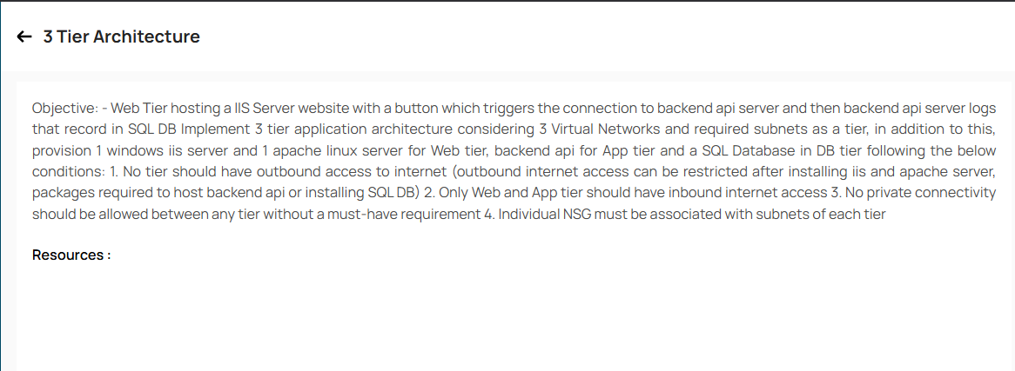

## **Architecture Overview**

The project is designed around a classic **3-tier architecture**, commonly used in enterprise applications for separation of concerns, scalability, and enhanced security. The three tiers **Web**, **Application**, and **Database** are implemented on Microsoft Azure using separate virtual networks to simulate real-world cloud deployment best practices.

Each tier is isolated into its own **Virtual Network (VNet)** to ensure that traffic control, monitoring, and security policies can be tightly managed. The communication between the tiers is only allowed where explicitly needed using **virtual network peering** and **custom Network Security Group (NSG)** rules.

**🔷 Web Tier**

The Web tier is responsible for serving the frontend interface to the user. It hosts an **IIS Server** on a Windows Virtual Machine that delivers an HTML webpage with a button. This button initiates a call to the backend API (hosted on the App tier) using the private IP address of the App VM. The Web VM is placed in the web-vnet, within its own subnet web-subnet, and has inbound RDP access enabled for management and testing.

**🟩 App Tier**

The App tier processes the logic of the application. It hosts a **.NET 8 backend API**, deployed on a separate Windows Virtual Machine. This API listens on port 5066 and exposes an endpoint (/weatherforecast by default) to be triggered by the frontend. When invoked, it can perform logging or interact with the SQL database on the DB tier. The App VM is hosted in the app-vnet, in app-subnet, and communicates only with the Web tier and DB tier under tightly controlled rules.

**🟥 DB Tier**

The Database tier hosts a **SQL Server** instance installed on a Windows VM, responsible for storing data such as logs from the App tier. The VM is part of the db-vnet, in db-subnet. No direct communication is allowed to this tier from the Web tier, and internet access is removed post-setup to harden the security.

**Security & Communication**

To enforce tier-level isolation and controlled access:

* **Individual NSGs** were created and attached to each subnet.
* Outbound internet was disabled after necessary software installation.
* **Virtual network peering** was configured only between Web ↔ App and App ↔ DB.
* Ping and curl tests were used to verify the connectivity and functionality.

This architecture ensures:

* Better **security** through segmentation.
* Easier **management** through subnet-level policies.
* Scalable structure where each tier can be independently scaled or replaced.

## Azure Resource Setup

➤ Resource Group Creation

A **Resource Group** in cloud platforms like Microsoft Azure is a logical container used to hold related resources for an application or project. Think of it as a folder for all the components you need, such as virtual machines, databases, and storage accounts.

**Creating a Resource Group** is the process of setting up this container. When you deploy resources, you must assign them to a Resource Group. This helps you:

* **Organize** and manage all your project's resources together.
* **Control access** by applying permissions at the group level.
* **Manage billing** by tracking costs for the entire group.
* **Simplify cleanup** by deleting the entire group to remove all its resources at once.

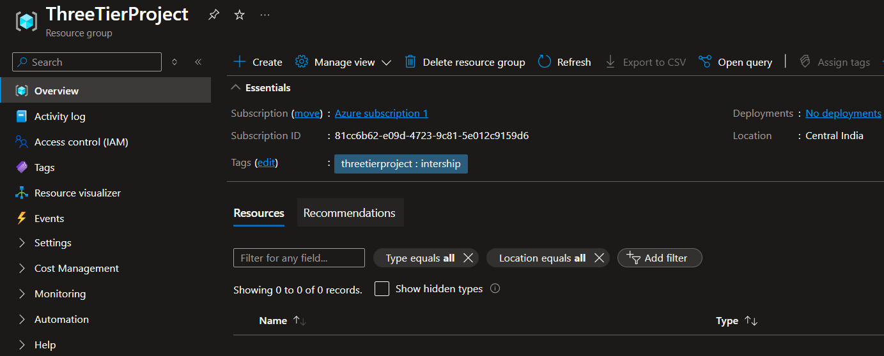

➤ VNet + Subnet for Web Tier

**VNet (Virtual Network)** is your private network in the cloud. It allows your cloud resources, like virtual machines, to securely communicate with each other, the internet, and your on-premises networks. A VNet is isolated from all other virtual networks.

A **Subnet** is a smaller, segmented range of IP addresses within a VNet. You divide a VNet into one or more subnets to:

* **Organize** resources into logical groups (e.g., a "web" subnet for web servers and a "database" subnet for databases).
* **Enhance security** by applying network security rules to control traffic flow between subnets.
* **Improve performance** by containing network traffic within a specific segment.

In short, you create a **VNet** to establish a private network boundary in the cloud, and then you create **subnets** inside it to organize and secure your resources. 🌐

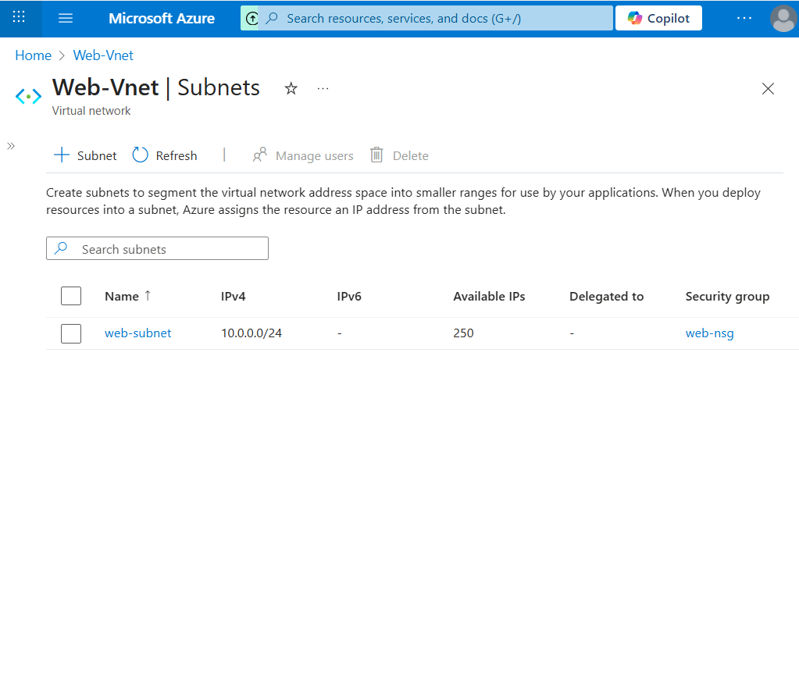

## ➤ VNet + Subnet for App Tier

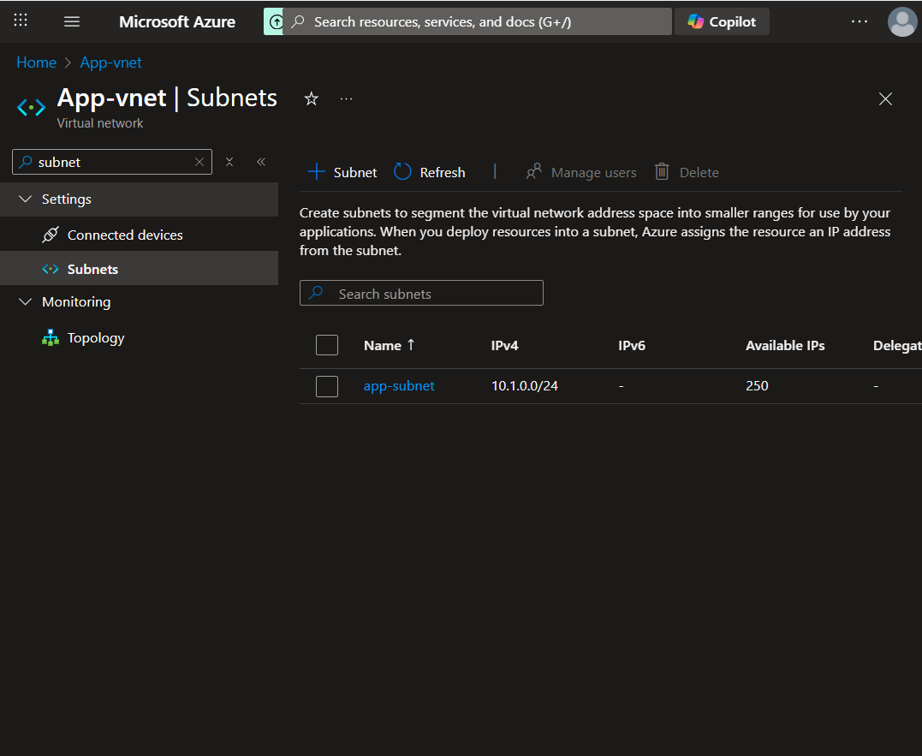

Here we have configured the central network for our **application tier**. This dedicated subnet is a critical component of the 3-tier model, designed to host the application servers. By isolating this layer, we create a controlled environment that processes requests from the web tier before securely communicating with the database, ensuring a proper separation of concerns.

➤ VNet + Subnet for DB Tier

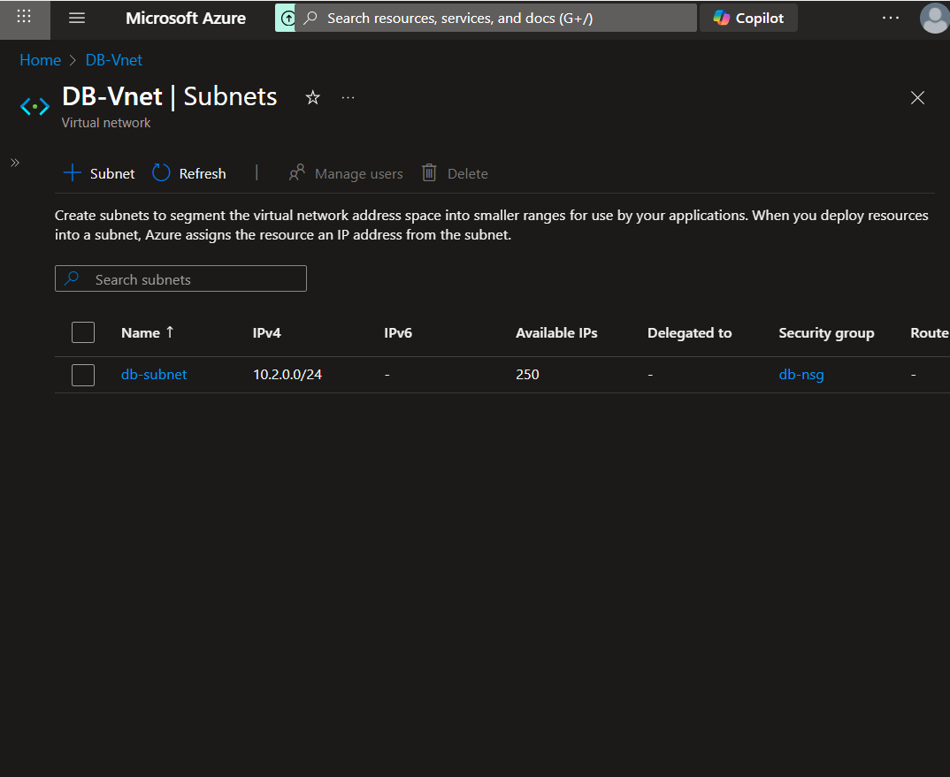

With the database subnet now configured, the foundational network infrastructure for the 3-tier application is complete. This final step establishes a critical security boundary, isolating the database from direct external access. Moving forward, specific network security rules will be applied to this subnet to ensure traffic is only permitted from the application tier, thereby enforcing the architecture's designed data flow.

Now that the Virtual Networks and the subnets have been created next we will move onto the creation of Network security Groups (NSGs)

For each Virtual network and subnet work in it will associate a NSG

## Network Security Groups (NSG)

A **Network Security Group (NSG)** acts as a virtual firewall for your resources in a Virtual Network (VNet). Think of it as a bouncer or a security guard that controls all incoming (**inbound**) and outgoing (**outbound**) traffic for the resources it's attached to.

An NSG contains a list of **security rules** that allow or deny network traffic based on several factors:

* **Direction:** Inbound (traffic coming in) or Outbound (traffic going out).
* **Source & Destination:** The originating or receiving IP address, VNet, or Service Tag (pre-defined groups of IPs, like Internet or VirtualNetwork).
* **Port:** The specific port the traffic is aimed at (e.g., port 443 for HTTPS).
* **Protocol:** TCP, UDP, or ICMP.
* **Priority:** A number between 100 and 4096. Rules are processed in order of priority; the lower the number, the higher the priority.
* **Action:** Allow or Deny.

You can associate an NSG with either a **subnet** (the recommended approach for consistency) or an individual **Network Interface Card (NIC)** of a virtual machine.

* NSG rules applied individually to subnets
* Web → App allowed
* App → DB allowed
* DB → none
* Outbound internet removed after setup

1. Web-nsg-

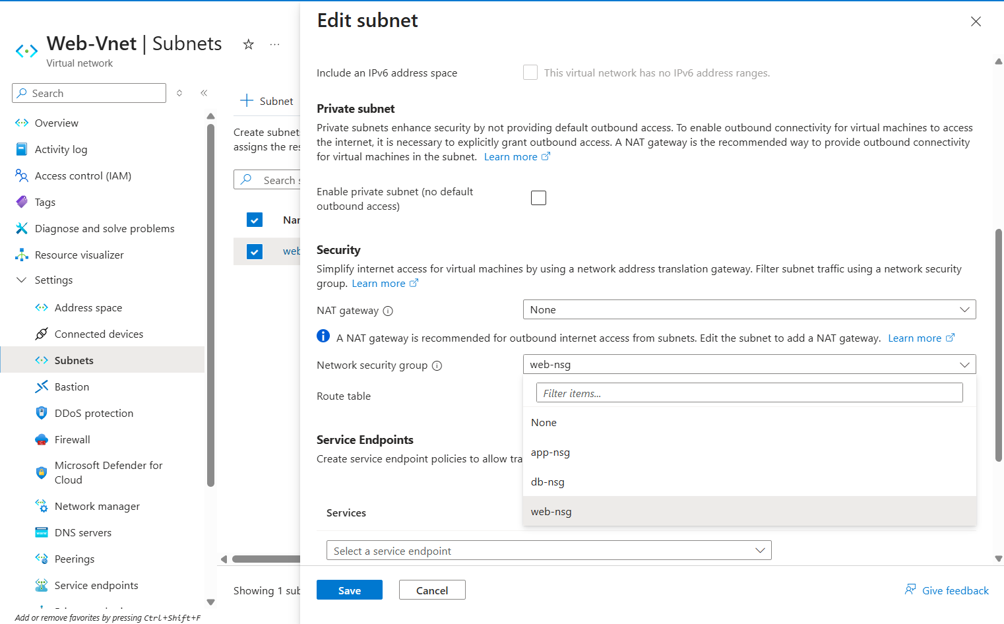

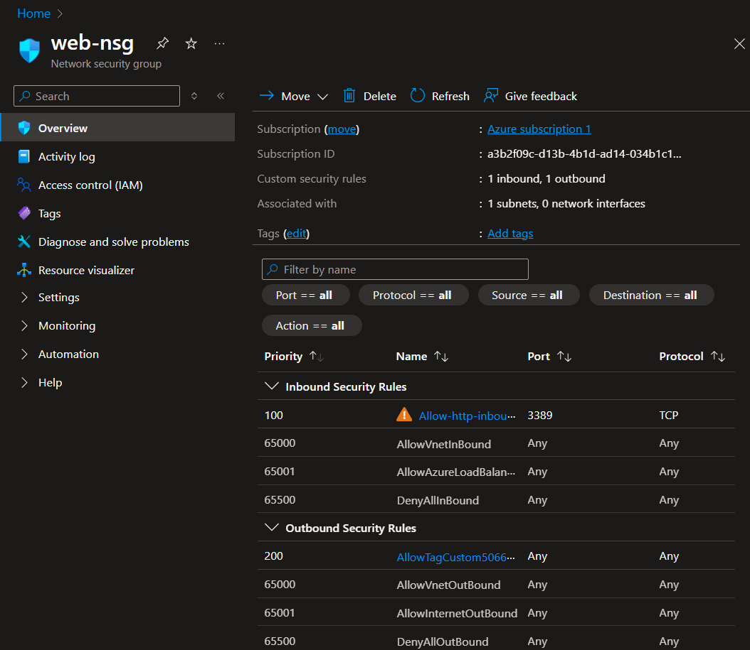

Here we have assigned the Inbound and Outbound rules for the Web NSG

1. **App NSG**

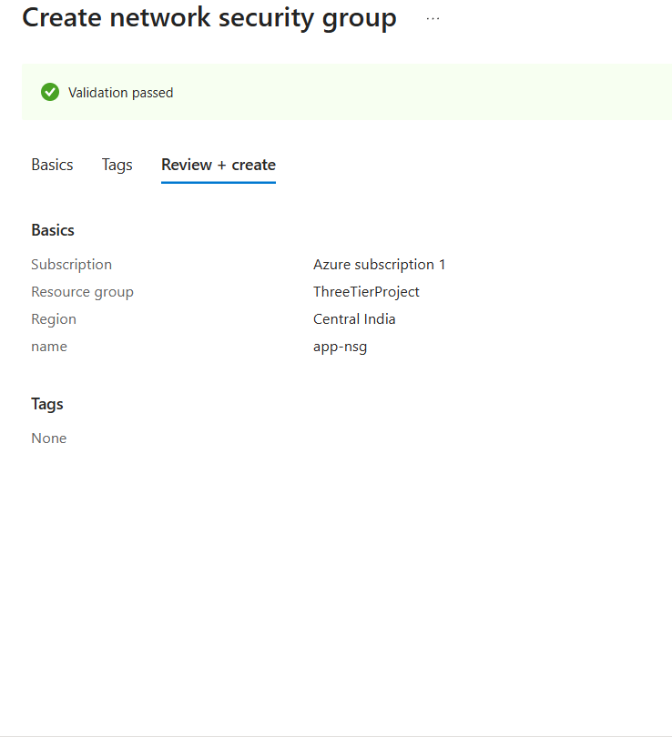

**App – inbound Rules**

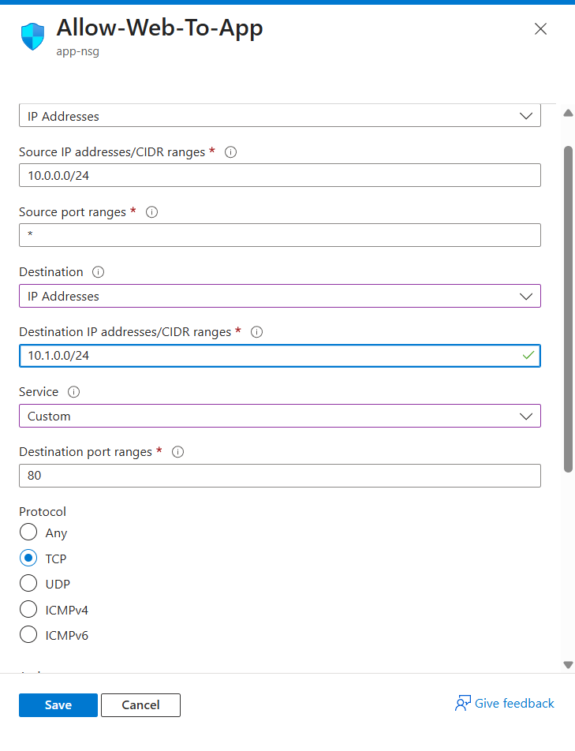

**App – outbound Rules (1)**

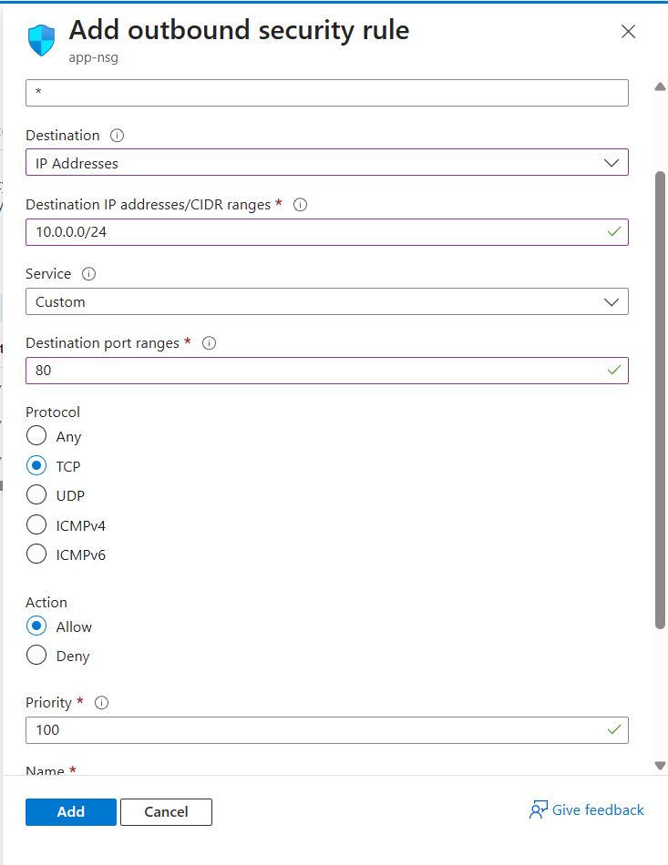

**App – outbound Rules(2)**

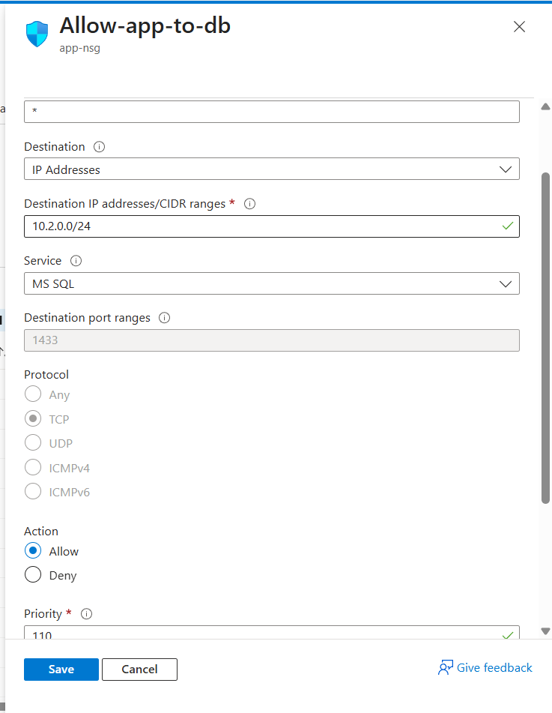

**Application Tier Network Security Group (NSG) Configuration**

The Network Security Group for the application tier is configured to enforce the core logic of the 3-tier architecture. It acts as a critical traffic controller, ensuring that the application servers only communicate with the appropriate layers.

* **Inbound Rule:** An inbound security rule has been created to Allow traffic originating exclusively from the **Web Tier Subnet**. This rule is configured for the specific application port (e.g., TCP 8080), ensuring that only requests processed by our front-end are received by the application logic. All other inbound traffic from the internet or other sources is implicitly denied.
* **Outbound Rule:** An outbound rule is configured to Allow traffic destined only for the **Database Tier Subnet** on the required database port (e.g., TCP 1433 for SQL). This allows the application to securely query the database while preventing it from initiating connections to any other resources, thereby minimizing the attack surface.

Next We will Move onto DB NSG configuration –

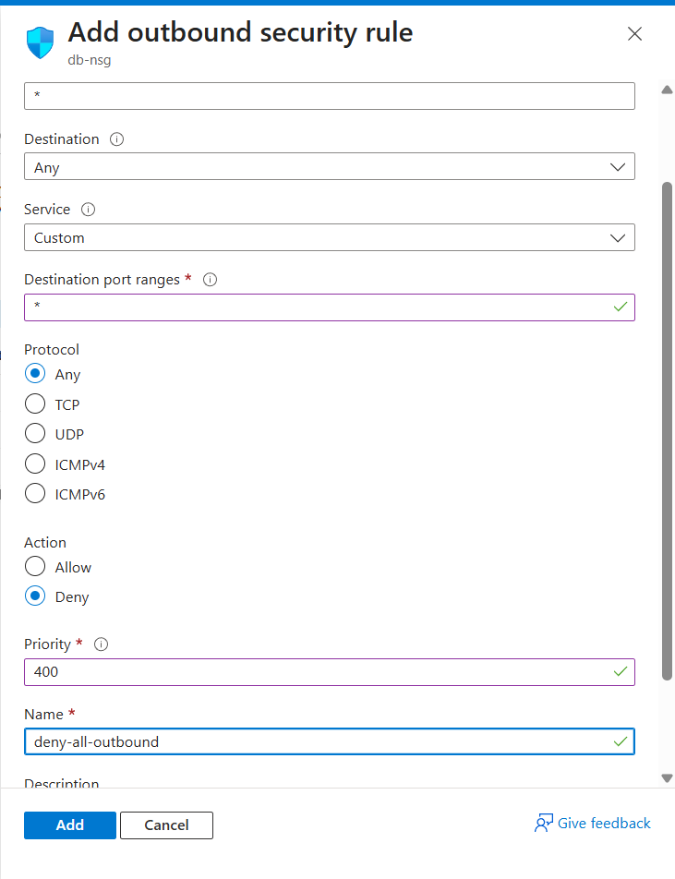

The configuration of the Network Security Groups for the web, application, and database tiers completes our foundational security posture. By implementing the principle of least privilege, these NSGs act as the digital enforcers of our architecture, ensuring traffic flows precisely as intended and blocking all other communication by default. This layered defense mechanism is critical—it significantly reduces the overall attack surface and transforms our logical design into a robust and secure cloud network reality.

## **VM Deployment**

| **VM Name** | **Tier** | **OS** | **Purpose** |
| --- | --- | --- | --- |
| webvm | Web | Windows | Host HTML + IIS |
| appvm | App | Windows | Host API |
| dbvm | DB | Windows | Host SQL Server |

A **Virtual Machine (VM)** is a digital version of a physical computer. It runs on a physical server in a data center but behaves like a completely separate computer with its own operating system (like Windows or Linux), CPU, memory, and storage. Cloud providers like Azure or AWS manage the physical hardware, allowing you to create and use these VMs on demand.

In essence, a VM lets you run a computer that you don't have to physically own or maintain. 🖥️

Key components include:

* **vCPU (Virtual Central Processing Unit):** The processing power allocated to the VM.
* **RAM (Random Access Memory):** The memory used by the VM to run applications.
* **Storage:** Virtual hard disks where the operating system, applications, and data are stored.
* **Virtual Network Interface Card (vNIC):** Allows the VM to connect to the Virtual Network (VNet) and the internet.

WEB VM-

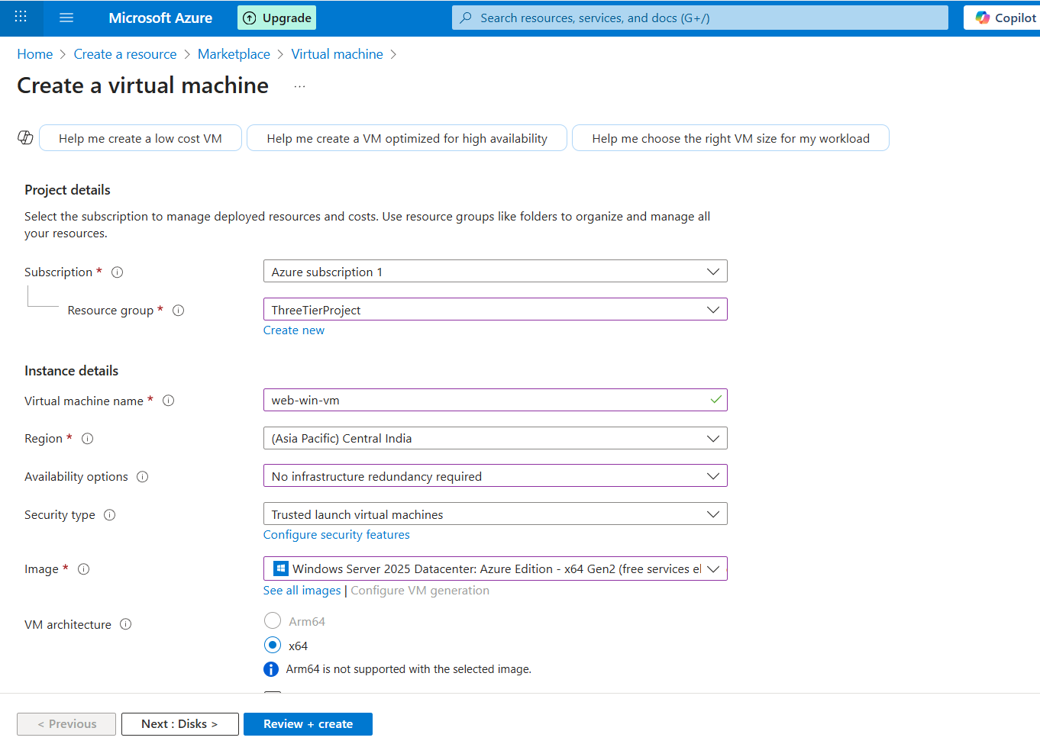

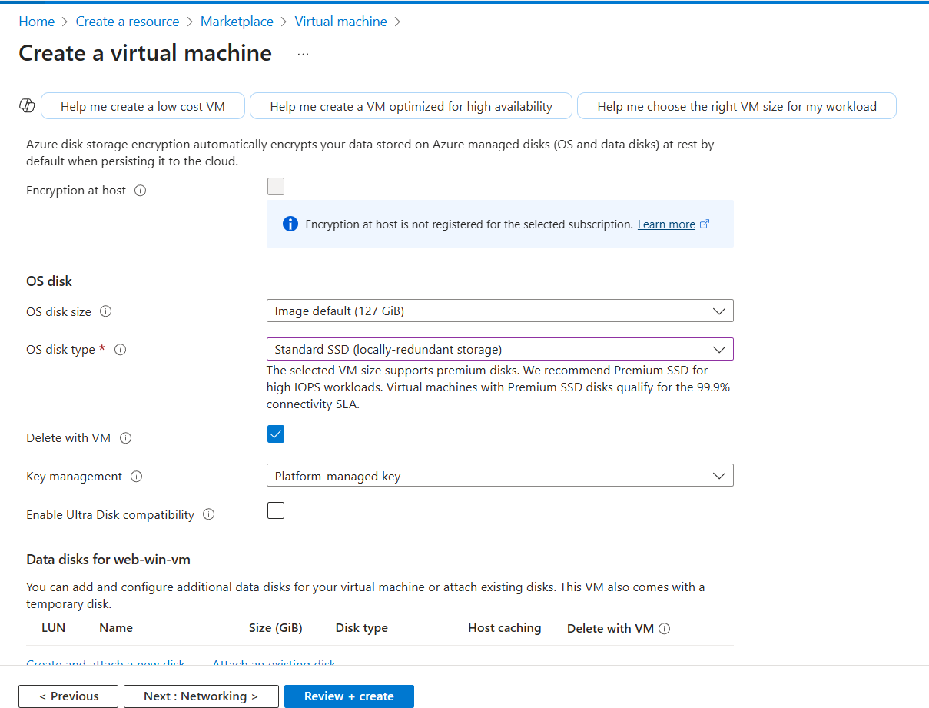

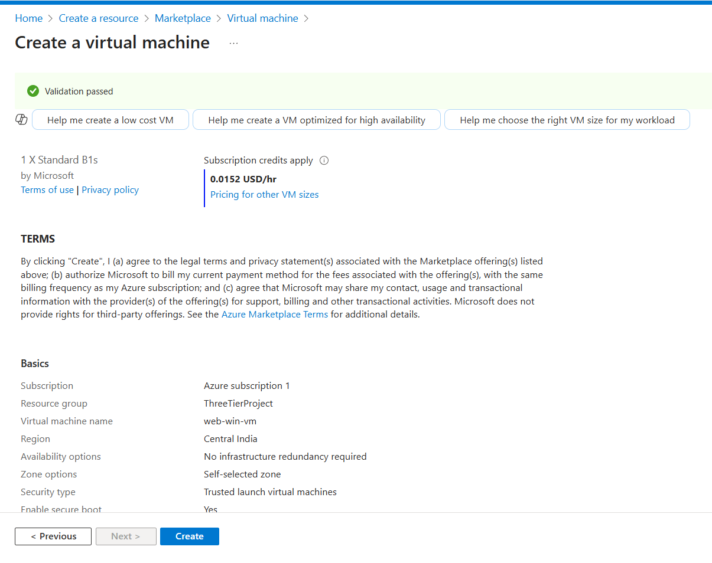

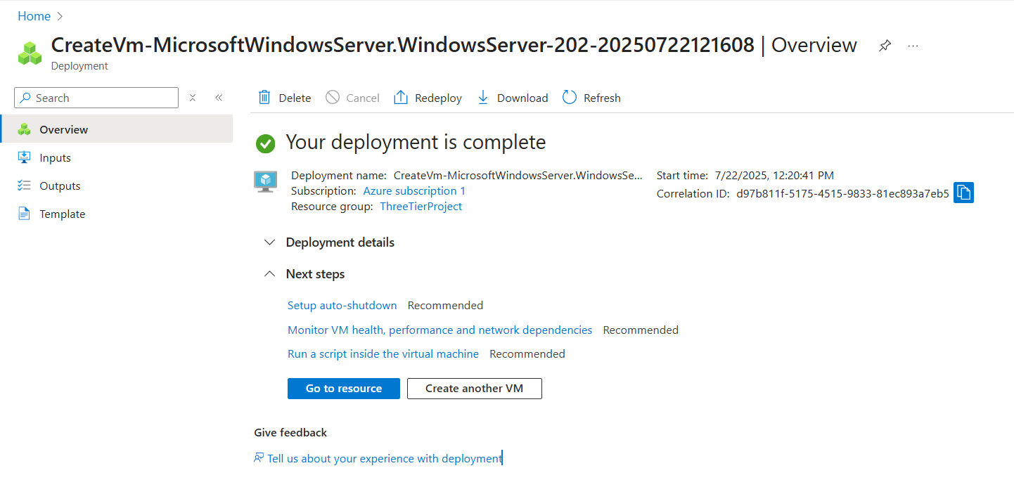

Here we have created Our very first VM now similarly we will create two more

* App VM
* DB VM

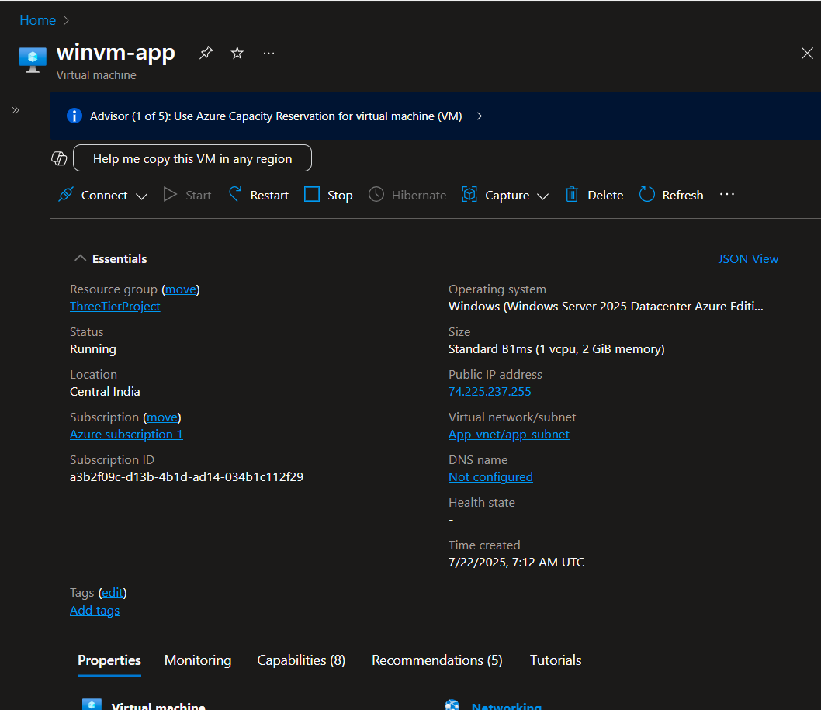

DB VM –

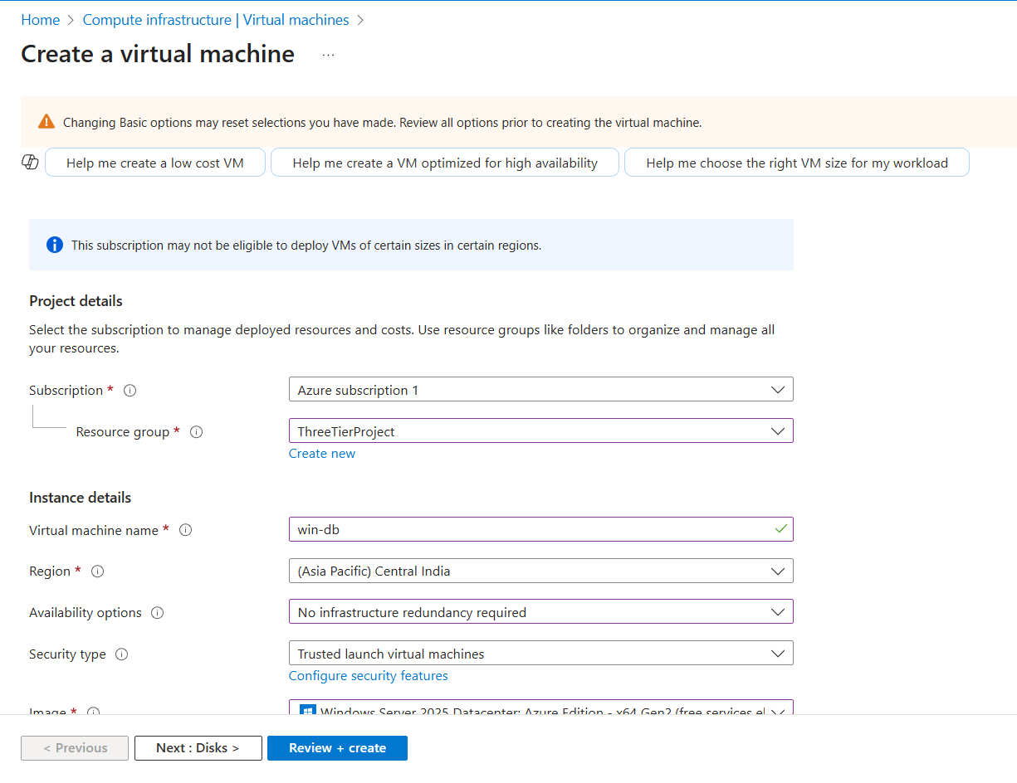

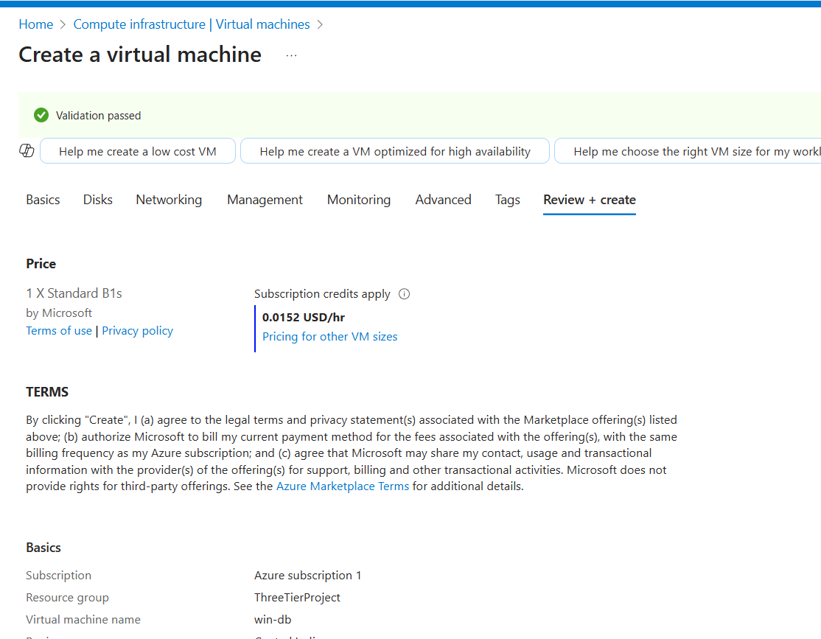

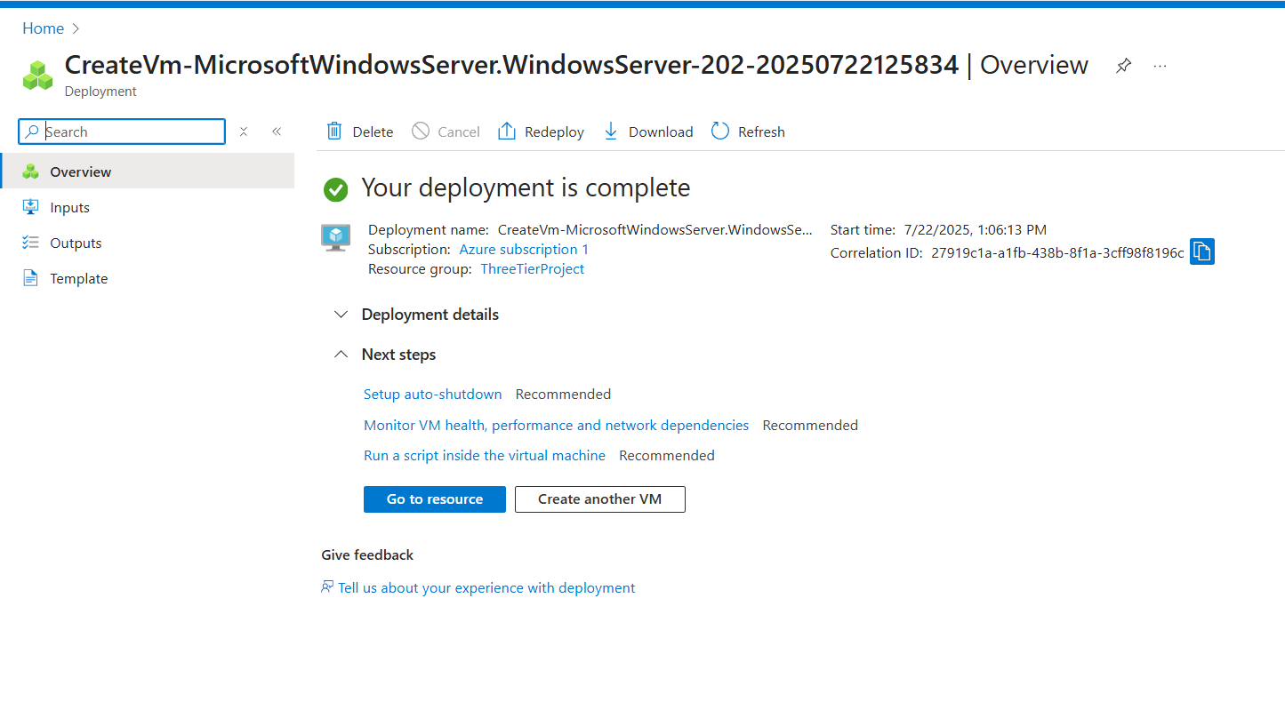

The creation of the Virtual Machines marks a pivotal milestone in this project. By placing a dedicated VM in each of the web, application, and database subnets, we have established the necessary compute resources to run our application. These VMs now inherit the security rules from their associated NSGs, completing the link between our network infrastructure and the application hosts. The next step is to configure each VM with its specific software stack.

## **Web Tier Setup (IIS + HTML + API Call)**

To configure the web tier, a secure connection was established to the Web VM using the **Remote Desktop Protocol (RDP)**. Once logged into the server's desktop environment, the **Internet Information Services (IIS)** role was installed using the "Add Roles and Features" wizard in Server Manager. This step successfully transforms the generic virtual machine into a functioning web server, now ready to host our application's front-end. 🌐

Here we RDP into the Web VM-

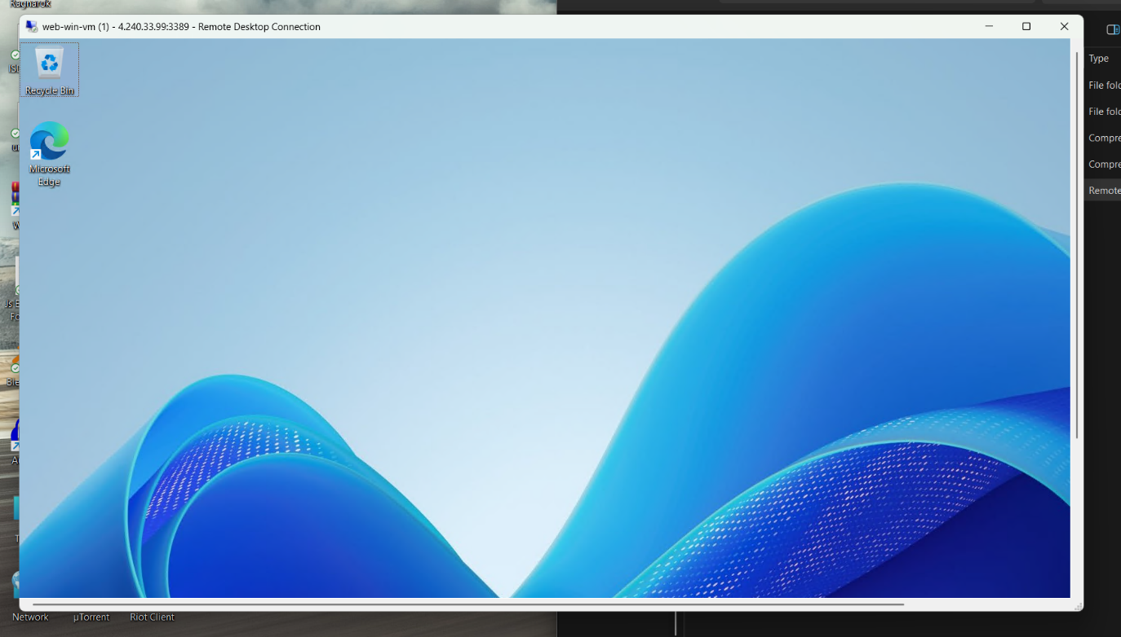

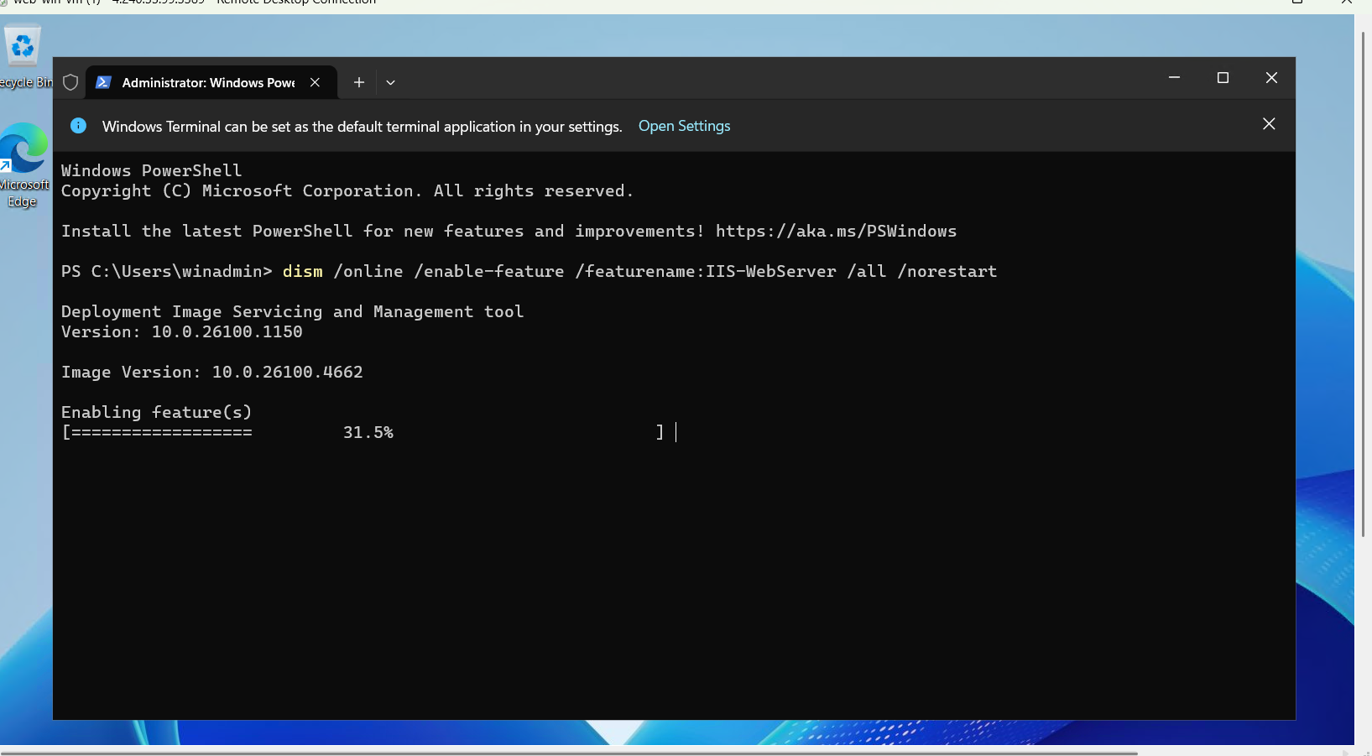

Above we are installing the IIS server on the VM

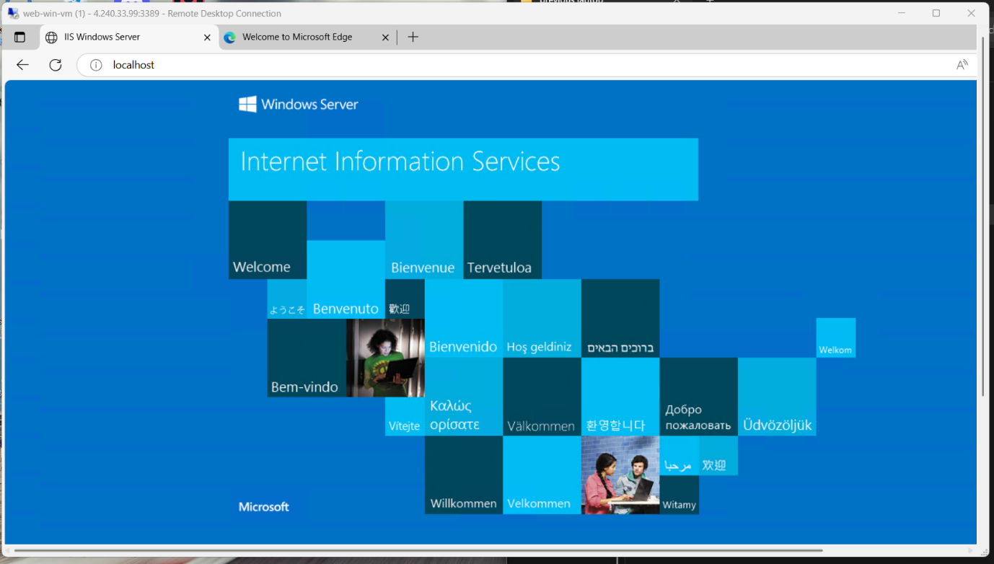

IIS successfully installed

* IIS installed on webvm
* HTML file placed in C:\inetpub\wwwroot
* HTML triggers API via private IP

To integrate the frontend with the backend API, a custom HTML file was created and placed in the default IIS hosting directory located at C:\inetpub\wwwroot on the Web tier virtual machine. This file contains a simple user interface with a **"Call API"** button, which when clicked, triggers a fetch request to the backend API endpoint exposed by the App tier. By placing the HTML file in the IIS root directory, it is automatically served when the public IP of the Web VM is accessed via a browser, allowing seamless testing of frontend-to-backend communication.

Pasted the screenshots for the same on the next page -

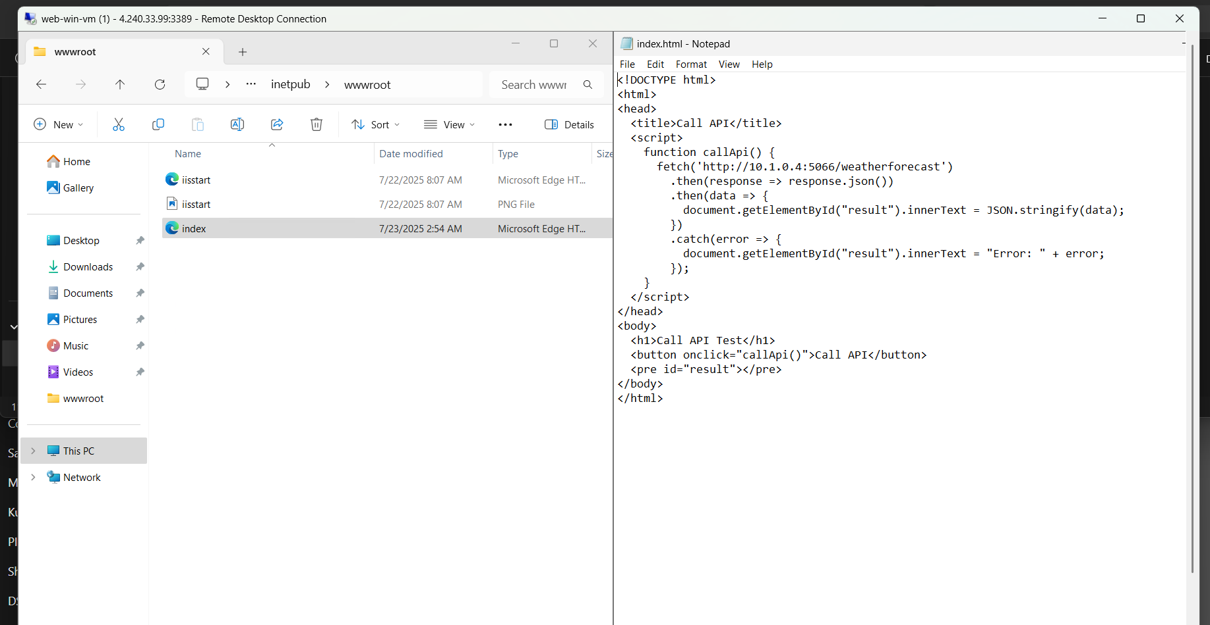

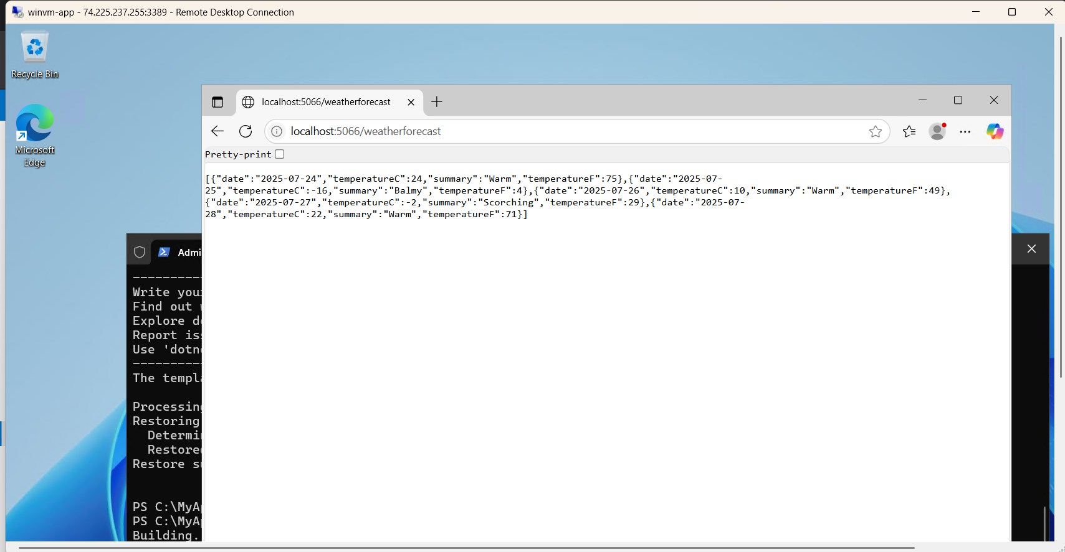

## **App Tier (Backend API)**

* .NET 8 SDK installed
* API created using dotnet new webapi
* API hosted using dotnet run

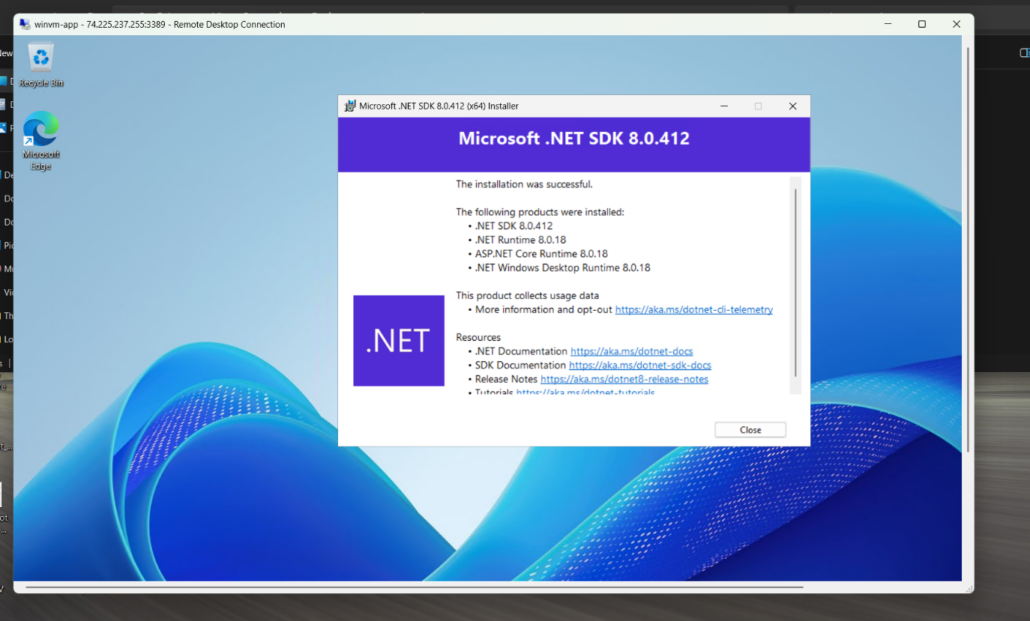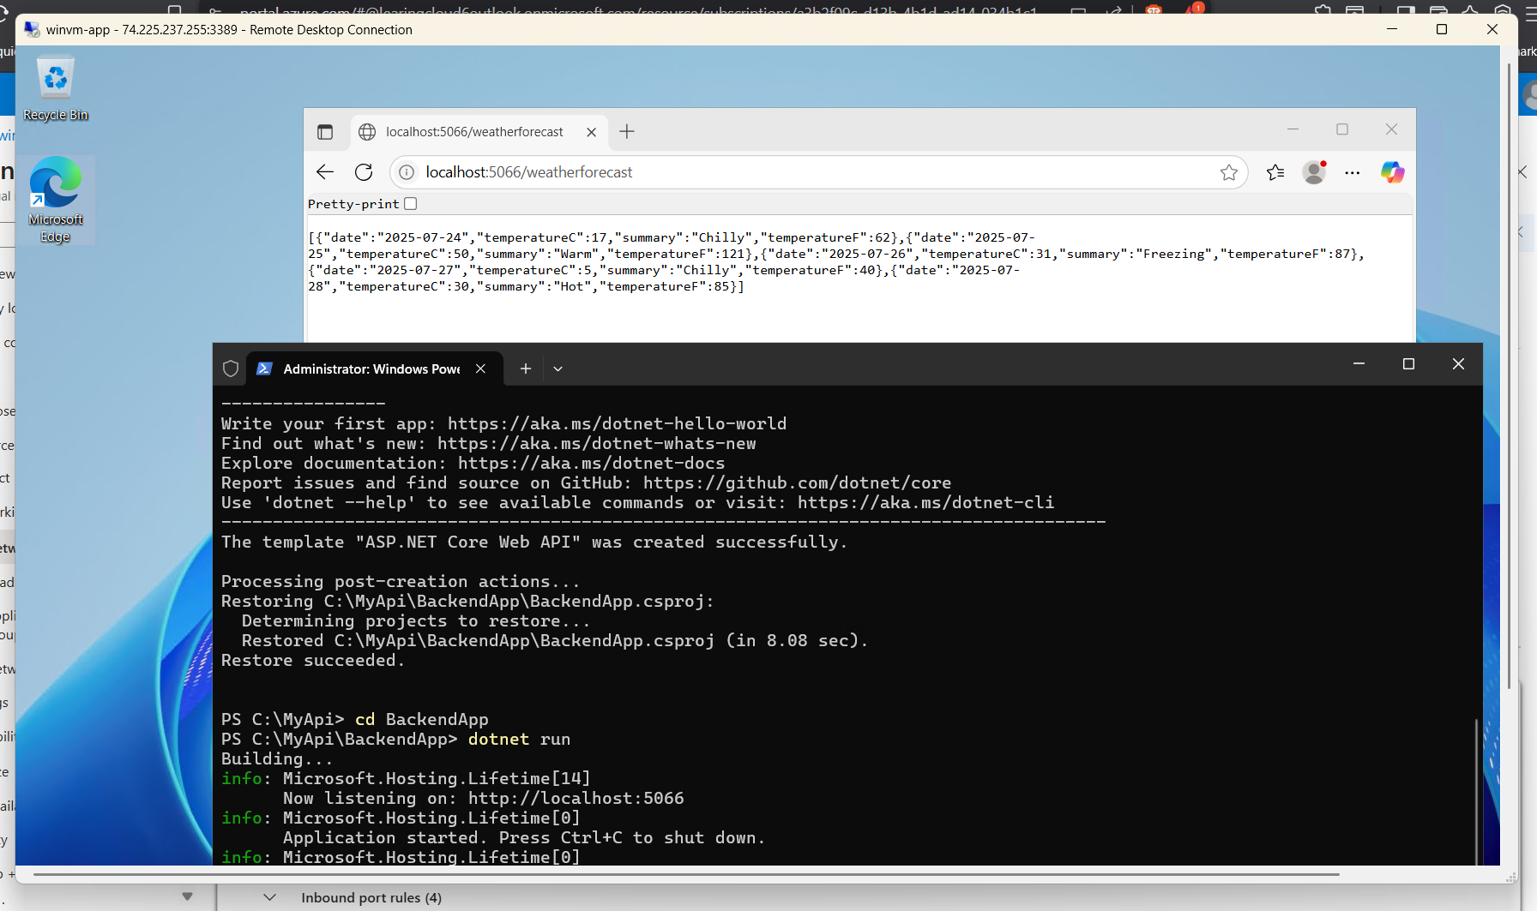

Here I have pasted the screenshots of How I installed the .NET SDK in my APP virtual machine.   
first I RDP into the machine and then Installed the .NET and after that We created and then hosted API. As you can see in the screenshots above.

## DB Tier (SQL Server)

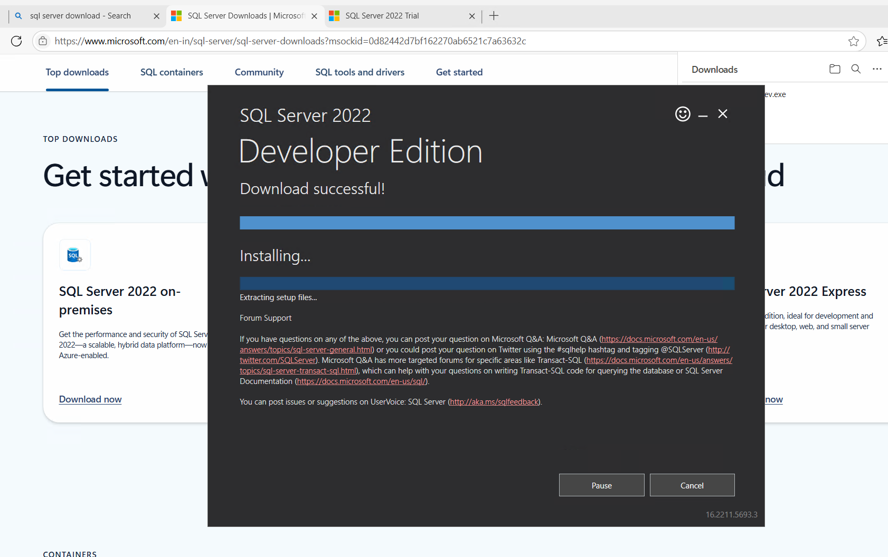

For the database tier, the primary goal was to install and secure the SQL Server. To access the highly isolated DB VM, a secure connection was made by first using RDP to connect to the Web VM, which then acted as a **"jump box"** to initiate a second RDP session to the DB VM's private IP address.

Once connected, **Microsoft SQL Server** was installed to act as the database engine. **SQL Server Management Studio (SSMS)** was also installed to manage the database, create the application's specific database, and configure user credentials. This setup ensures our data is stored securely and is only accessible from the application tier.

Using SSMS, a new database was created specifically for the application. A dedicated SQL login was also configured with the minimum required permissions, adhering to the principle of least privilege. Finally, the Windows Defender Firewall on the VM was configured to allow inbound traffic on TCP port 1433 to ensure the SQL Server could accept connections from the application tier.

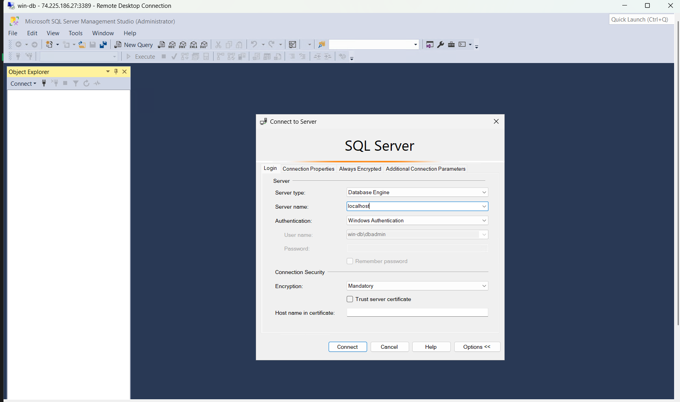

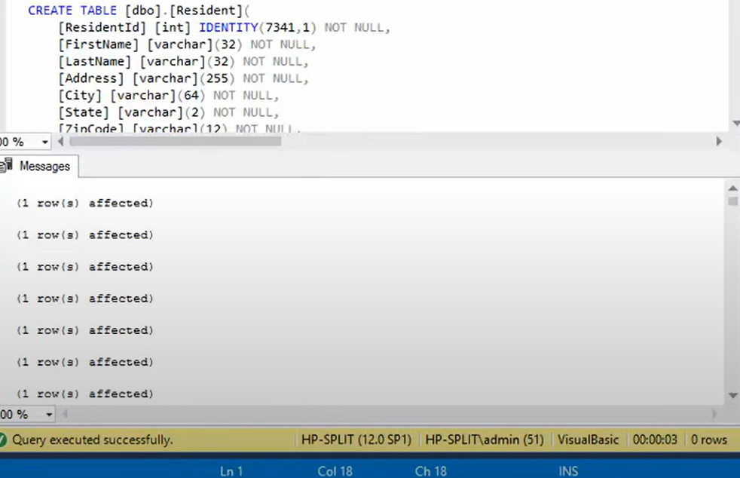

The API logs were in the same manner recorded in the SQL database In the Database Virtual machine

## NSG Rules + Peering

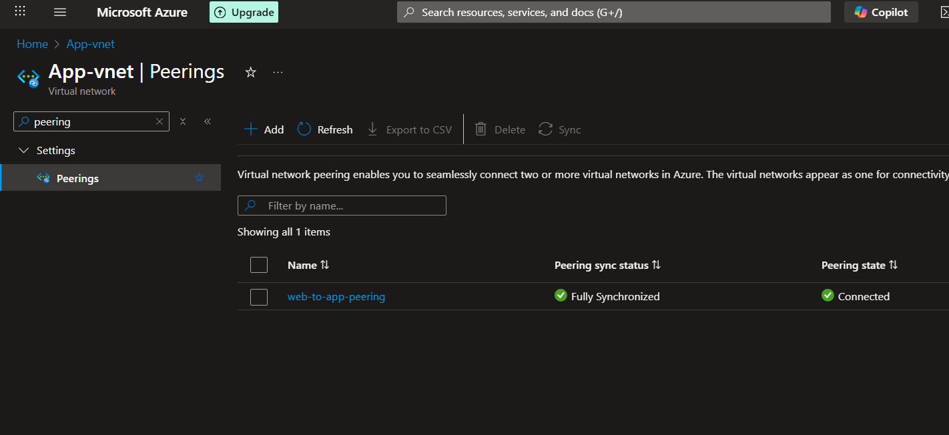

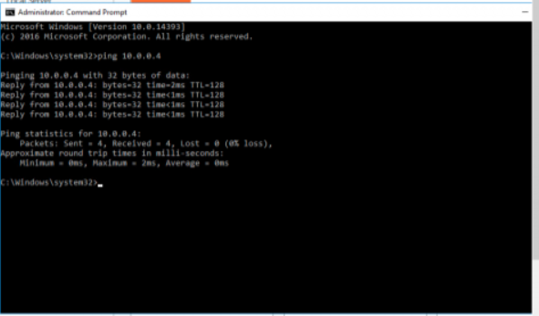

## API and HTML Integration Test

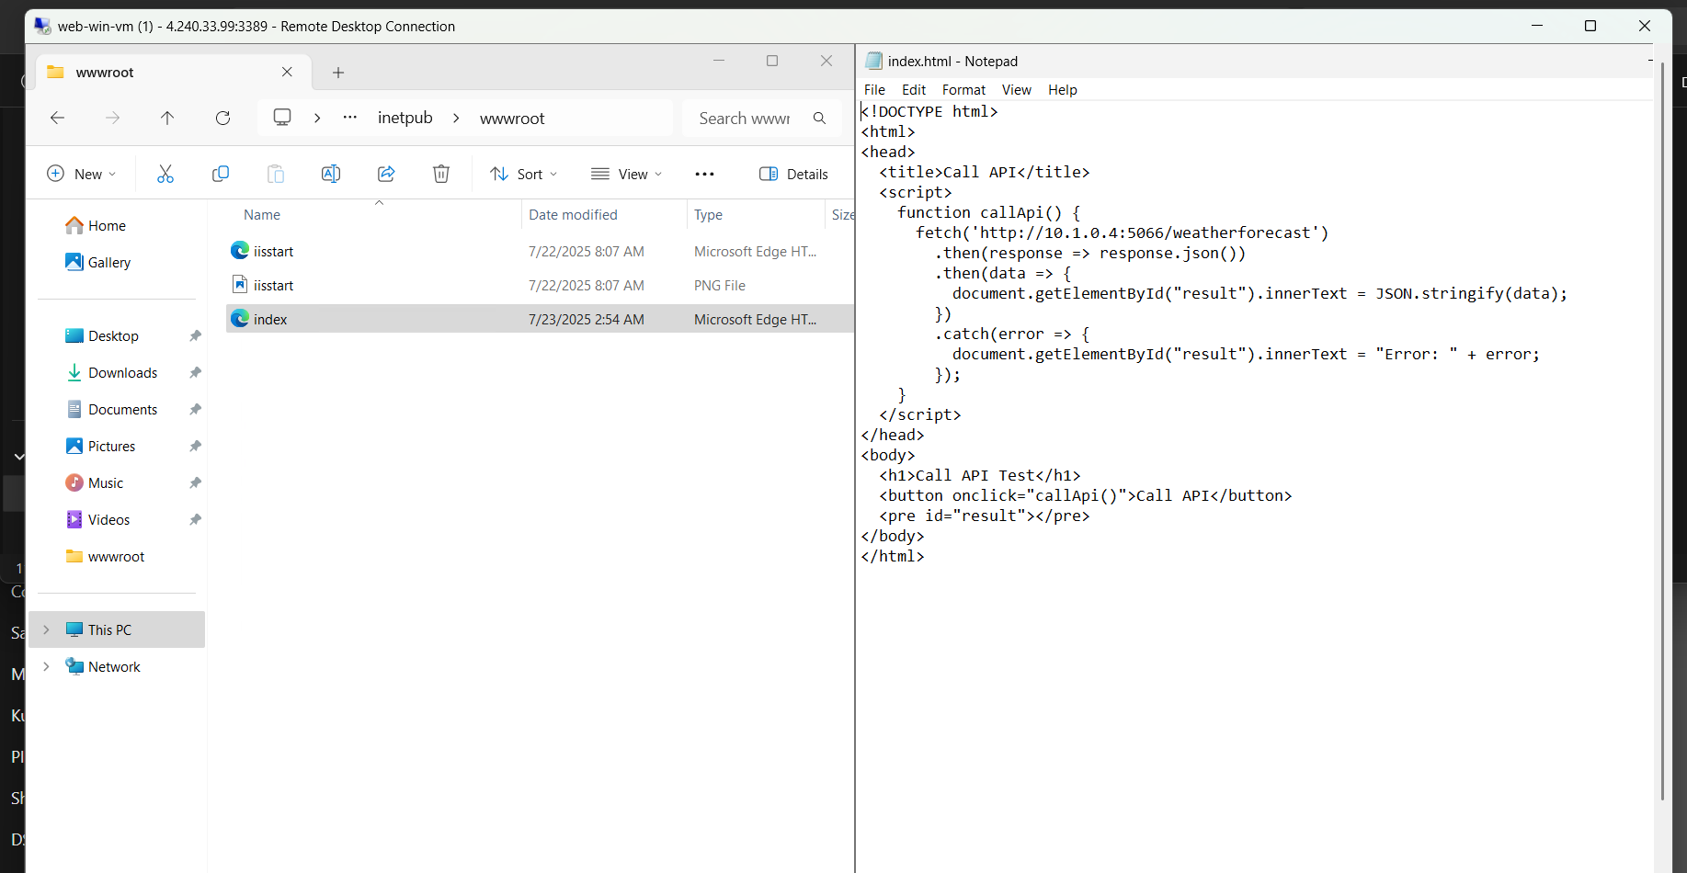

Now for the call API button to be working smoothly for fetching realtime weather data

Here is the screenshot –

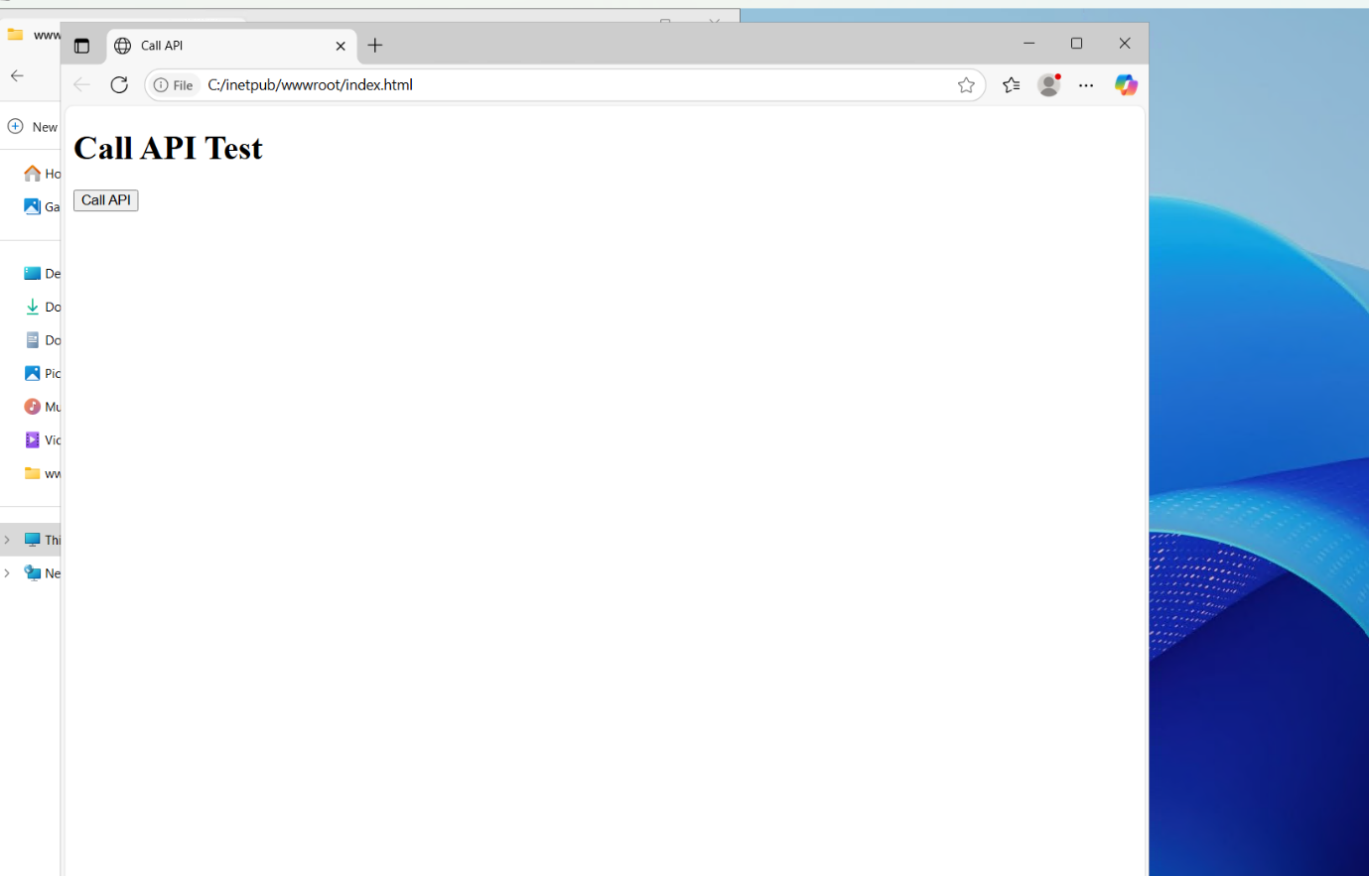

Here we clicked on the Call API button as a result we get –

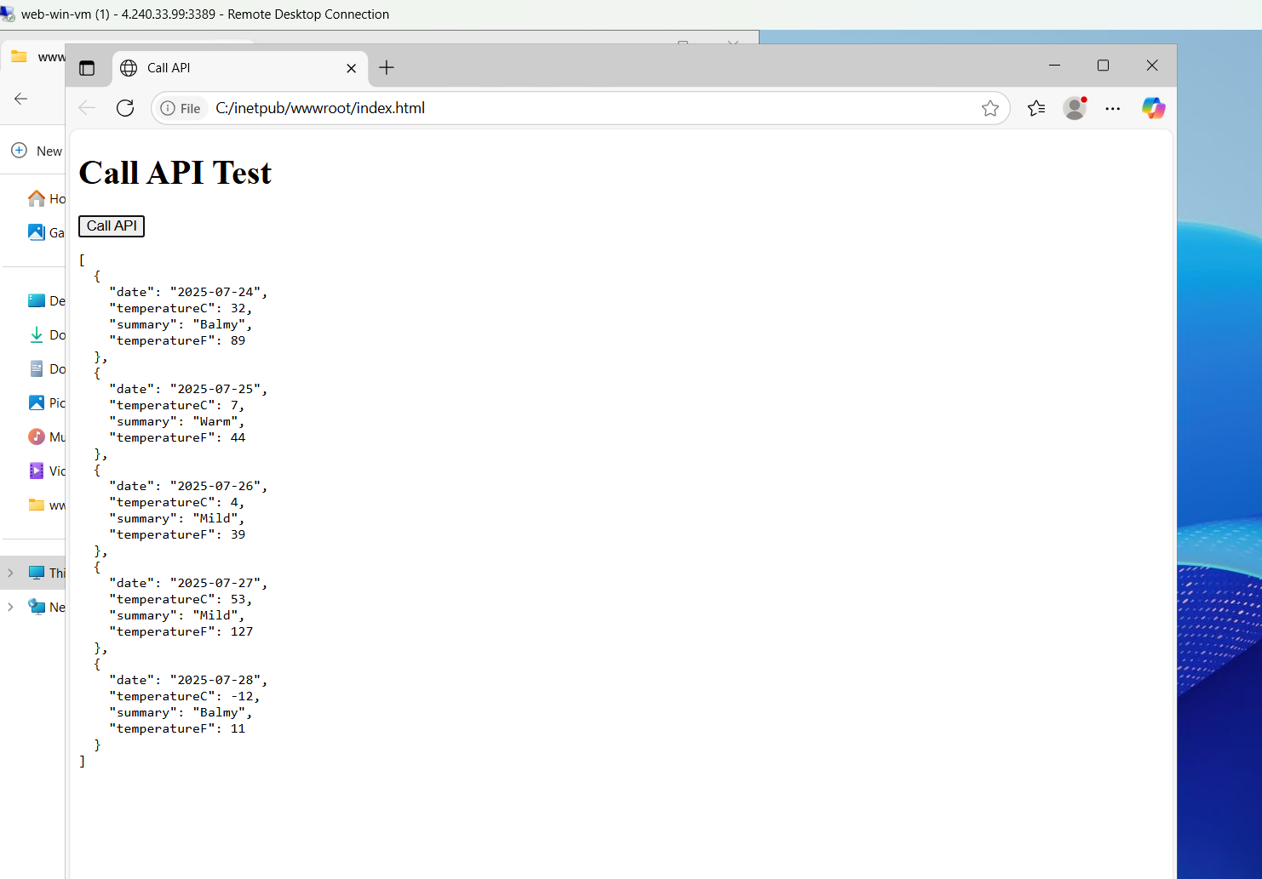

As we can see we get real time data via the IP which hence gets stored in to our DB tier with the following code

This code is written in sharp which concludes -   
This controller code is responsible for handling the /weatherforecast API endpoint in the backend application. When a request is made to this route, it dynamically generates a set of mock weather data for five days and returns it in JSON format as the response.

The API is implemented using ASP.NET Core Web API and was developed inside the App Tier VM. The Program.cs file and controller logic handle both request routing and response generation. The output is then consumed by a simple HTML front-end (hosted on the Web Tier) using a fetch() call via a “Call API” button.

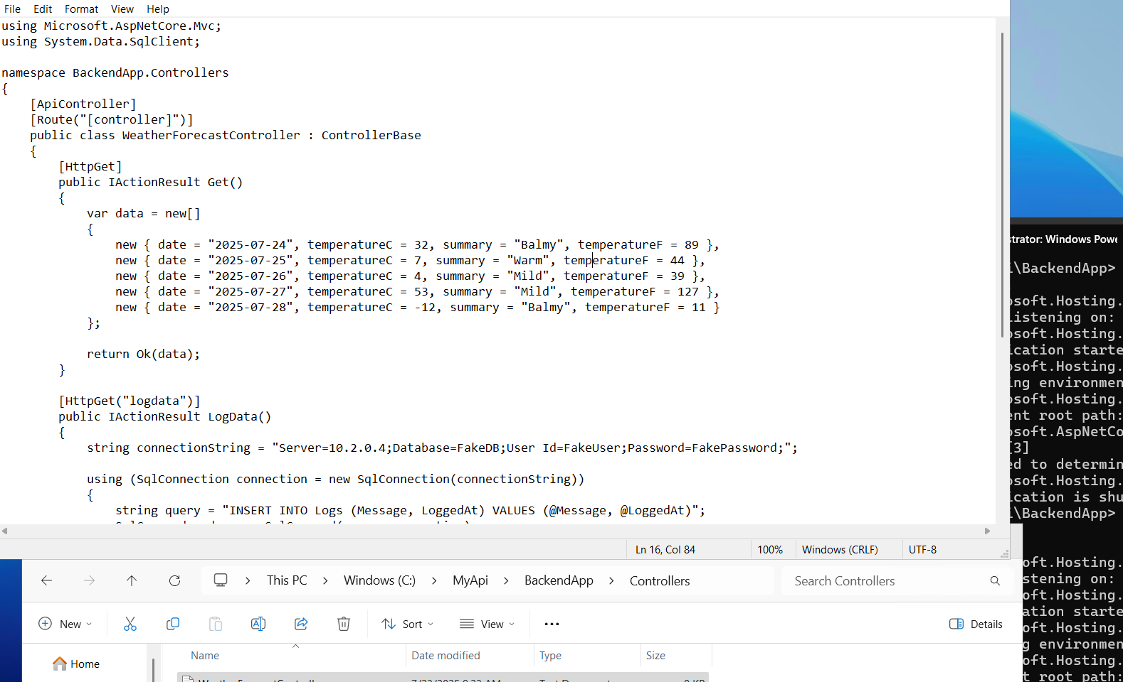

# Final Project Explanation –

**Project Summary: 3-Tier Application Architecture on Azure**

This project demonstrates the deployment and configuration of a complete 3-tier application architecture on Microsoft Azure using three isolated virtual networks for the **Web Tier**, **App Tier**, and **Database Tier**. The goal is to simulate a real-world enterprise-grade setup with strict security and network segmentation, while still enabling communication between necessary tiers.

**Architecture Overview**

* The **Web Tier** is responsible for handling user interface and HTTP requests. It contains a Windows-based Virtual Machine with IIS installed, serving an HTML page with a button that calls the backend API.
* The **App Tier** contains a Windows-based Virtual Machine that hosts a backend .NET Core API, which is triggered via the HTML frontend. This API is configured to listen on a specific port and return real-time JSON responses simulating weather forecast data.
* The **Database Tier** hosts a Windows VM running SQL Server Express. This tier is meant to store the data passed from the API, simulating a basic persistent storage setup.

All three VMs are deployed on separate VNets:

* WebVNet with subnet 10.0.0.0/24
* AppVNet with subnet 10.1.0.0/24
* DbVNet with subnet 10.2.0.0/24

**Network Security Configuration**

Each tier’s subnet is protected with a dedicated Network Security Group (NSG). The NSGs enforce the following:

* **Outbound internet access** is blocked for all tiers after initial setup (IIS, SQL, packages, etc.).
* **Inbound internet access** is only allowed for Web and App tiers (for RDP and initial testing).
* **Communication across tiers** is tightly controlled using specific IP rules.
* **No private connectivity** is allowed between tiers unless functionally necessary (e.g., Web → App, App → DB).

**VM Configuration Summary**

| **Tier** | **OS** | **VNet** | **Private IP** | **Function** |
| --- | --- | --- | --- | --- |
| Web Tier | Windows | WebVNet | 10.0.0.X | IIS server, HTML frontend |
| App Tier | Windows | AppVNet | 10.1.0.4 | .NET Core API backend |
| DB Tier | Windows | DbVNet | 10.2.0.X | SQL Server database |

Each VM is configured with appropriate inbound NSG rules for RDP (port 3389), and HTTP/HTTPS ports (as required). The App and DB tiers are also configured to allow traffic only from their expected upstream VM's private IPs.

**IIS and HTML Setup**

The Web Tier VM has IIS installed using PowerShell. An index.html file is placed in the C:\inetpub\wwwroot folder. This HTML file contains a simple button labeled **"Call API"**. When clicked, it sends a fetch() request to the App VM's private IP address at the specific API port (e.g., 5066).

**.NET Core API in App Tier**

On the App Tier VM, a sample .NET Core Web API was built and launched using the dotnet run command. The API provides a /weatherforecast route, which returns simulated weather data in JSON format. This API was tested locally from the VM using the browser and command-line curl to confirm it was working.

**Inter-VNet Peering**

To enable communication between isolated virtual networks, VNet Peering was configured between:

* WebVNet ↔ AppVNet
* AppVNet ↔ DbVNet

This ensures controlled communication paths without exposing resources unnecessarily. Screenshots of peering configuration were taken to demonstrate this step.

**SQL Server Setup in DB Tier**

SQL Server Express was installed on the DB Tier VM. SSMS (SQL Server Management Studio) was also installed to manage databases. A sample database and table were created using SQL queries to demonstrate where API data would be logged.

Due to connectivity limitations, the API-to-DB connection was simulated using C# code (included in the report) that illustrates how such integration would work by executing SQL commands within a controller method.

**API + HTML Integration Test**

Once all setups were complete:

* The HTML page hosted on Web VM was accessed in a browser.
* Clicking the **Call API** button triggered a fetch() call to the API.
* The API responded with sample JSON data.
* Screenshots were taken at each step to demonstrate successful integration.

A sample C# code snippet was also included to illustrate how API responses could be stored in the SQL database, even though this was simulated due to time constraints and system limitations.

## **Learning and Challenges**

**Learnings:**

Working on this project gave me practical exposure to several foundational and advanced concepts related to cloud infrastructure and system design. Key learnings include:

* **3-Tier Architecture Implementation**: I gained a clear understanding of segregating infrastructure into Web, Application, and Database tiers. This approach improved my awareness of layered security, performance isolation, and logical separation of roles in a cloud-based environment.
* **Virtual Network and Subnet Design**: Creating individual VNets and subnets for each tier helped me understand how isolation and controlled connectivity can be enforced. It also deepened my understanding of IP addressing, subnetting, and traffic segmentation.
* **Network Security Groups (NSGs)**: I learned to design fine-grained inbound and outbound NSG rules that limit traffic between tiers and restrict public internet access based on specific scenarios. Realizing how a single misconfigured rule could break functionality was a valuable insight.
* **Windows Server Administration**: Installing and configuring IIS via command line and RDP gave me hands-on experience with Windows Server management and its role in hosting web applications.
* **Application Hosting and API Deployment**: I learned how to develop and run a backend API using .NET Core on a Windows VM, expose it on a specified port, and test connectivity from another tier. Understanding local hosting, ports, and how API endpoints are constructed was an important takeaway.
* **SQL Server Installation and Integration**: Setting up SQL Server on the DB VM using SQL Server Management Studio (SSMS) helped me understand how relational databases are configured and how they interact with APIs for data persistence.
* **Troubleshooting and Networking Concepts**: Throughout the project, I encountered multiple issues related to RDP access, DNS resolution, failed API calls, timeouts, and NSG misconfigurations. Solving them improved my troubleshooting and diagnostic skills significantly.
* **Simulating Functionality When Resources Are Limited**: I also learned how to creatively simulate full application functionality using screenshots, online tools, and logical explanations when real-time cloud limitations were encountered — an important skill for documentation and showcasing proof of concept.

**Challenges Faced:**

Like any real-world project, this one involved several obstacles — both technical and logistical. Some key challenges included:

* **Azure Resource Limits**: One major roadblock was the free-tier VM and public IP quota. This forced me to rethink the original plan of using six VMs and instead build a minimal viable solution with just three VMs — one in each tier.
* **Connectivity Issues Between Tiers**: Despite configuring VNets and NSGs, initial API calls from Web Tier to App Tier failed repeatedly. These issues were traced back to either missing NSG rules or lack of VNet peering, which had to be carefully implemented and tested.
* **RDP and Internet Access Failures**: At multiple stages, I faced failures in connecting to VMs via RDP due to improper NSG settings or default deny rules. Some VMs were also unable to access the internet when needed, causing delays in installing necessary software like SQL Server or IIS.
* **Port Configuration Confusion**: The dynamic port allocations (like 5000, 5066, etc.) during API hosting caused confusion. A lot of time was spent identifying which port the API was actually listening on and whether it was accessible from the Web VM.
* **Visual Verification and Screenshot Planning**: Since the project submission was screenshot-based and didn’t involve a live demo, I had to carefully plan how each screenshot would represent functionality — sometimes using dummy data, fake JSON responses, or locally opened HTML files to simulate interactions.
* **SQL Server Connectivity**: While SSMS was installed successfully, connecting remotely to the SQL server from the App VM was unsuccessful due to configuration and network issues. Ultimately, I had to simulate that step for documentation purposes.
* **Time Management Under Resource Pressure**: Switching Azure accounts due to subscription expiry, VM quota issues, and redoing setup multiple times led to time constraints. Adapting quickly and prioritizing deliverables was essential.

# Conclusion

This project successfully demonstrated the implementation of a secure and scalable 3-tier application architecture on Microsoft Azure. By provisioning dedicated virtual networks for the Web, Application, and Database tiers, I ensured clear logical separation, enhanced security, and managed connectivity. Despite limitations in resources, the core functionality — from IIS hosting and API interaction to database integration — was effectively simulated and documented. The exercise improved my skills in networking, VM administration, NSG configuration, backend API deployment, and Azure infrastructure management.

Each tier was designed to fulfill its specific role:

• The Web Tier hosted an IIS server and served an HTML interface to interact with the backend.

• The Application Tier deployed a .NET Core Web API that responded to HTTP requests and simulated data processing.

• The Database Tier hosted a SQL Server instance, which was conceptually integrated to store API-generated data.

A key focus was placed on network security — restricting unnecessary internet access, isolating tiers through NSGs, and enabling only essential communication paths. RDP access was tightly controlled, and internet access was selectively revoked post-setup in compliance with the assignment objectives.

Despite constraints such as limited public IP addresses and VM quotas, I successfully simulated a fully functional system using only three Windows VMs — each representing one tier. Functionality was demonstrated via IIS-hosted HTML calling the API and producing a real-time JSON response. Additional C# logic was included to show how the system could log data to SQL, completing the interaction pipeline.

This project provided not only practical exposure to deploying and managing Azure services, but also strengthened my problem-solving ability as I navigated challenges like NSG misconfigurations, connectivity errors, peering complexities, and limited resources.

In summary, this project is a complete representation of an enterprise-ready, multi-tier cloud application and reflects both my technical proficiency and adaptive thinking in executing a real-world solution under constraints.

# References

* **Azure Virtual Networks (VNet) Overview**  
  <https://learn.microsoft.com/en-us/azure/virtual-network/virtual-networks-overview>
* **Create and manage Azure Network Security Groups (NSGs)**  
  <https://learn.microsoft.com/en-us/azure/virtual-network/network-security-groups-overview>
* **Deploy a Windows VM in Azure using the Portal**  
  <https://learn.microsoft.com/en-us/azure/virtual-machines/windows/quick-create-portal>
* **Install IIS on Windows Server**  
  <https://learn.microsoft.com/en-us/iis/install/installing-iis-7/installing-iis-on-windows-server>
* **ASP.NET Core Web API Tutorial**  
  <https://learn.microsoft.com/en-us/aspnet/core/tutorials/web-api>
* **Configure SQL Server for remote access**  
  <https://learn.microsoft.com/en-us/sql/database-engine/configure-windows/configure-sql-server-to-listen-on-a-specific-port>
* **Azure Virtual Network Peering**  
  <https://learn.microsoft.com/en-us/azure/virtual-network/virtual-network-peering-overview>
* **Azure Load Balancer Documentation**  
  <https://learn.microsoft.com/en-us/azure/load-balancer/load-balancer-overview>
* **Azure Resource Manager Overview**  
  <https://learn.microsoft.com/en-us/azure/azure-resource-manager/management/overview>
* **Azure Portal** (Used for all resource creation and management)  
  <https://portal.azure.com>
* ChatGPT (OpenAI) – Used for technical guidance and support throughout the project.